id | No Button «Sumbit»
2 | Steps:  - Go to https://pkrv.dp.gov.ua/  - Skroll down to News section  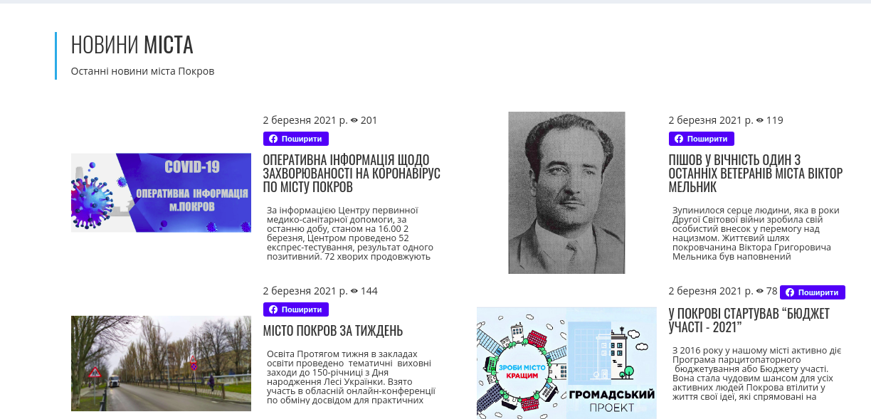  - Click «Наступнi новини» button    Expected result: News are update and have «Поширити» button    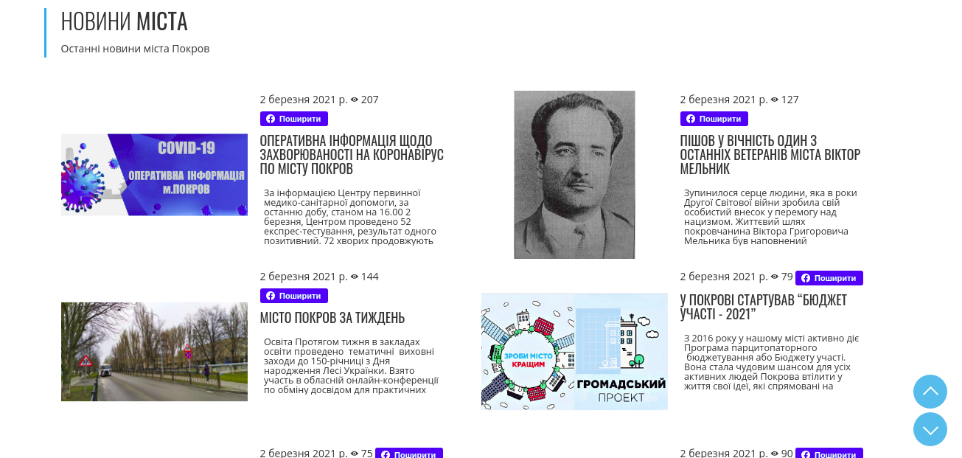  Actual result: News are update and don’t have «Поширити» button  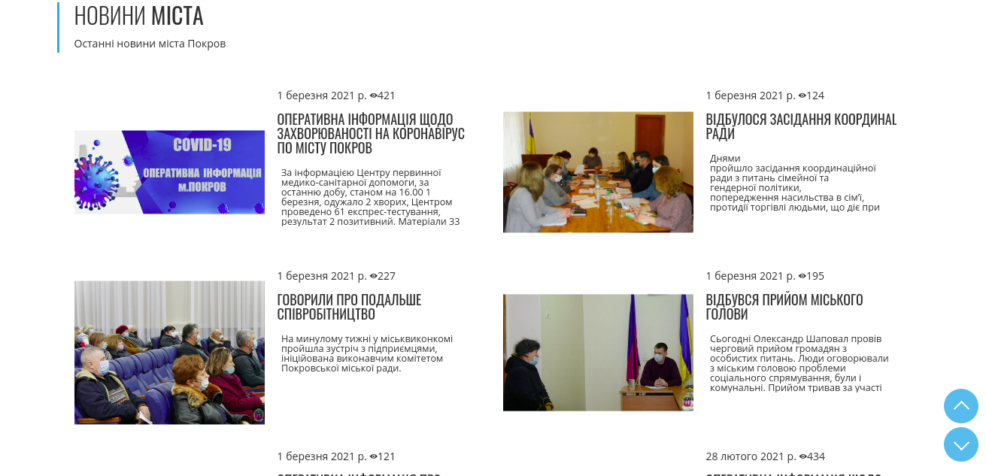  Browser use:  - Google Chrome for Ubuntu 88.0.4324.182 official 64-bit  - Mozila Firefox for buntu 86.0 64-bit  - Opera for Ubuntu Core 18 (x86_64; GNOME) 74.0.3911.160  OS use :  Ubuntu 20.04.2 LTS  Gnome 3.36.8

